Experiment - 2
Operating Systems Lab
Syeda Reeha Quasar
14114802719
6C7
AIM
To write about and execute various Linux commands.

EXPERIMENT – 2

Aim:

To write about and execute various Linux commands.

Linux Commands:

1. mkdir:

2. ls:

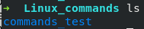

3. cd:

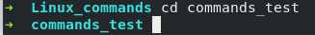

4. pwd:

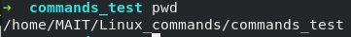
Created a file through VIM for executing further commands:
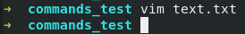
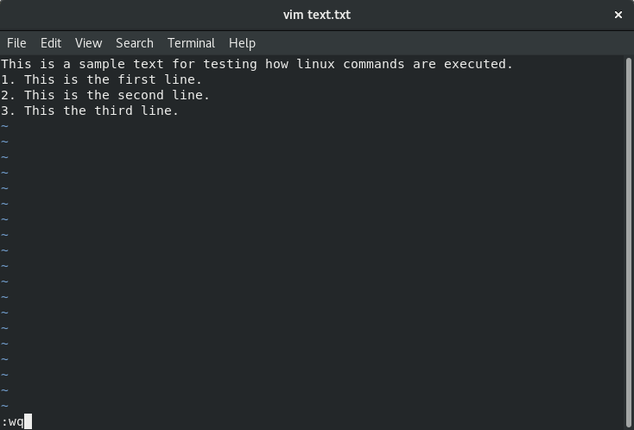

5. cat:

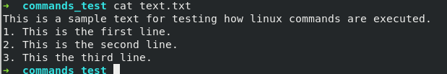

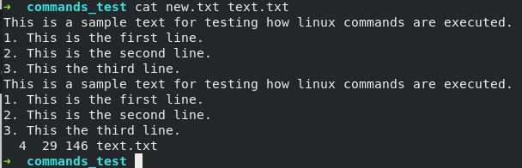

5. wc:

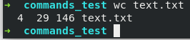

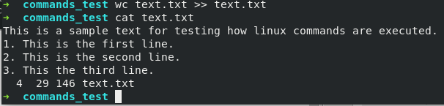

6. file:

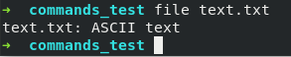

7. echo:

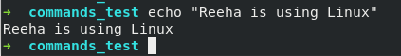

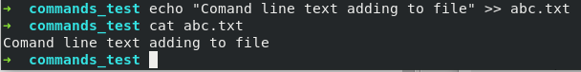

8. cp:

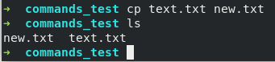

9. touch:

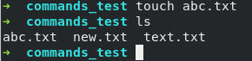

10. rm:

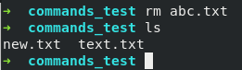

11. rmdir:

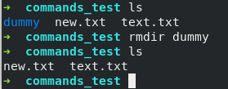

12. diff:

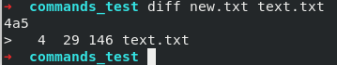

13. head:

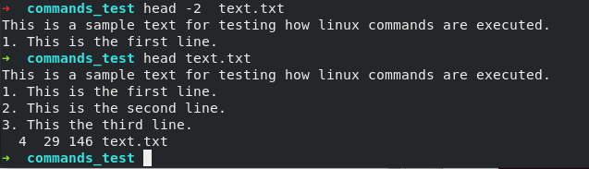

14. tail:
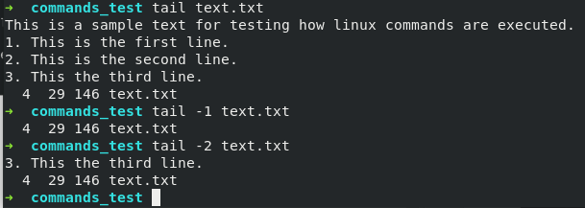

Piping

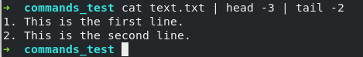

15. sort

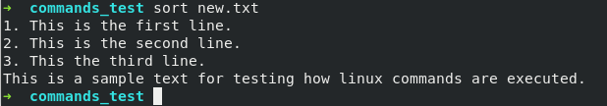

16. chmod

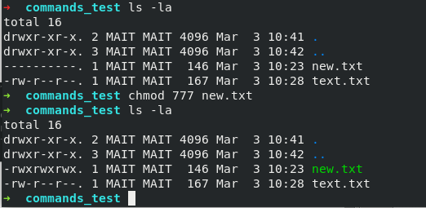

17. ps

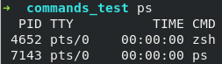

18. date

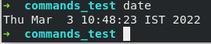

19. find

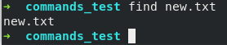

20. who

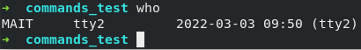

21. vmstat

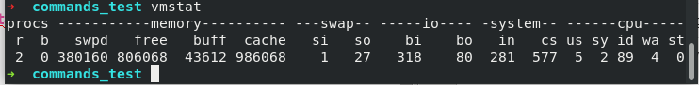
22. users

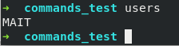

23. w

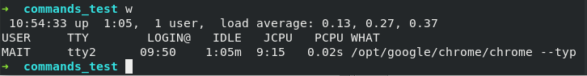
24. netstat

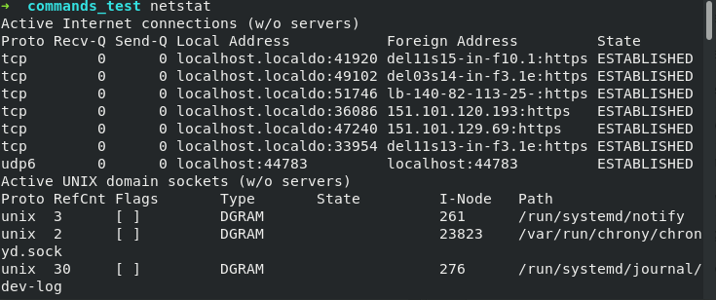
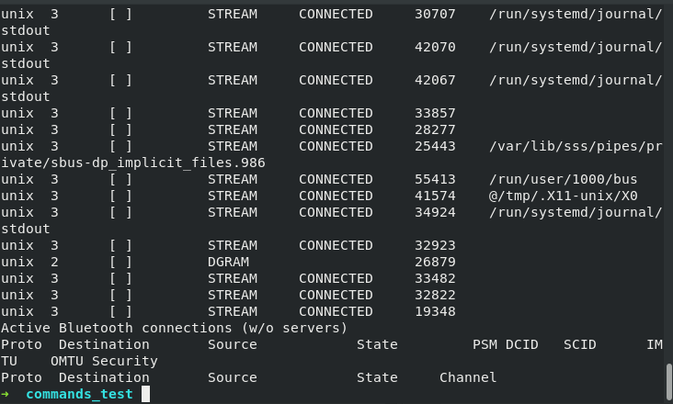

25. wget

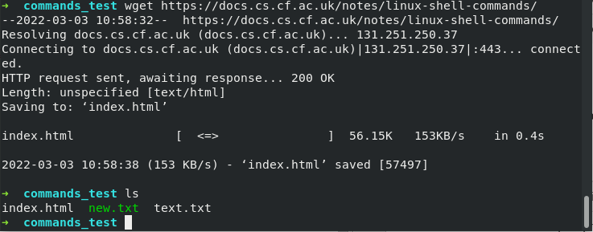

Viva Questions

1. Which are the Shells used in Linux?
Ans.

The most common Shells used in Linux are
bash: Bourne Again Shell is the default for most of the Linux distributions
ksh: Korn Shell is a high-level programming language shell
csh: C Shell follows C like syntax and provides spelling correction and Job Control
zsh: Z Shell provides some unique features such as filename generation, startup files, login/logout watching, closing comments etc.
fish: Friendly Interactive Shell provides some special features like web-based configuration, auto-suggestions, fully scriptable with clean scripts

2. Explain file permission in Linux.
Ans.
There are 3 kinds of permission in Linux:
- Read: Allows a user to open and read the file
- Write: Allows a user to open and modify the file
- Execute: Allows a user to run the file.

3. Which are the different modes of vi editor?
Ans.
There are 3 modes of vi editor:
- Regular/Command mode: Lets you view the content
- Insertion/edit mode: Lets you delete or insert content
- Replacement mode: Lets you overwrite content

4. What are the process states in Linux?
Ans.
The process states are as follows:
- Ready: The process is created and is ready to run
- Running: The process is being executed
- Blocked or wait: Process is waiting for input from the user
- Terminated or Completed: Process completed execution, or was terminated by the Operating System
- Zombie: Process terminated, but the information still exists in the process table.

5. Explain the ‘ls’ command in Linux
Ans.
The ls command is used to list the files in a specified directory. The general syntax is:
$ ls <options> <directory>

